Products Grid with Angular Material
In this exercise, you will
- Add Product Grid component
- Add Product Card Cart component
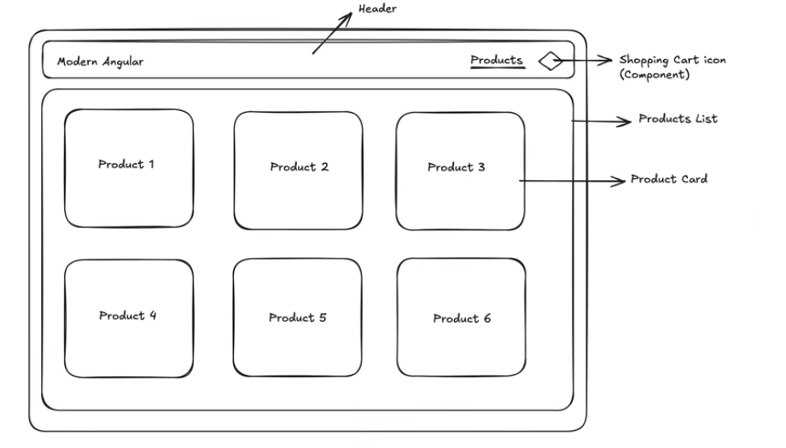
- Continue from previous store application. Make sure that the Terminal Server is there and run the web project.
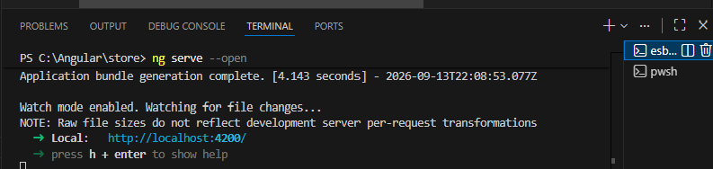

- Should have another Terminal window ready for other task. In this Terminal window, run the command ng g c products/products-grid
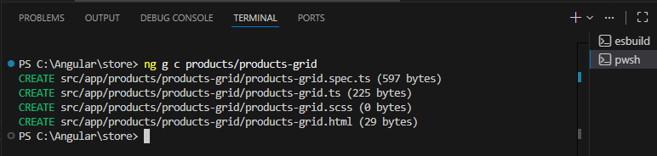

- Copy the selector from producs\produtcs-grid.ts
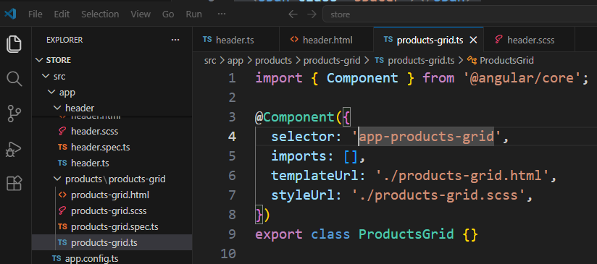

- Paste this selector to app.html inside a new <main> tag.
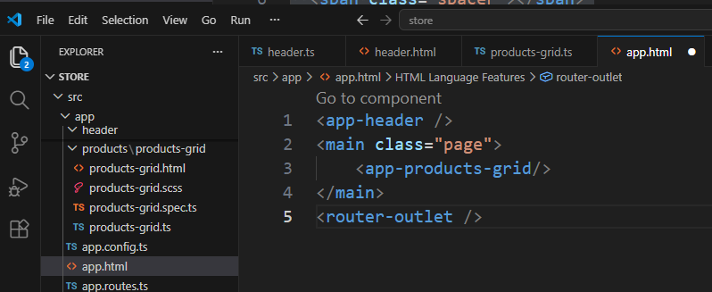

Note: Ignore if the error occurs. We might not yet import this component in app.ts
- In the app.ts
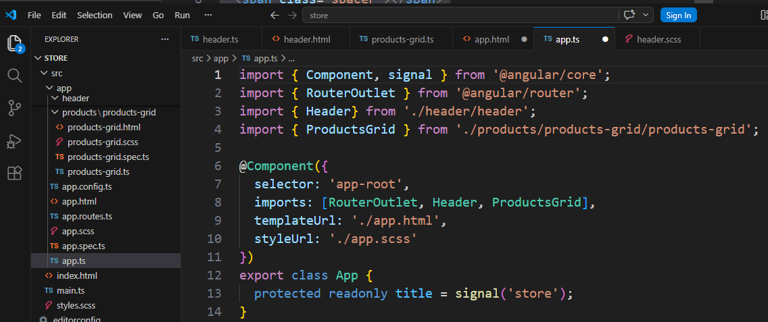

- Add SCSS script to app.scss
.page{
padding: 16px;
max-width: 1200px;
margin: 0 auto;
}

- Save All, now the web page should look like this
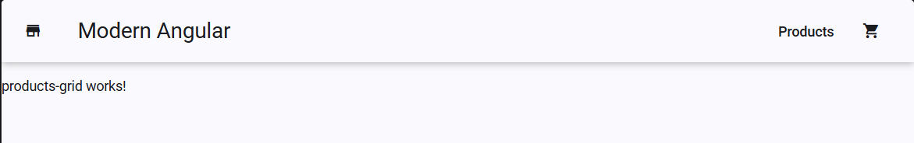
- Next, we will create product-cart component from Terminal by running command
ng g c products/product-card
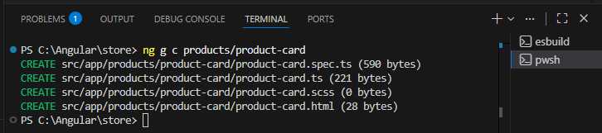
- This Product-Card component needs a MatCardModule component. In the TS file, let’s add it in
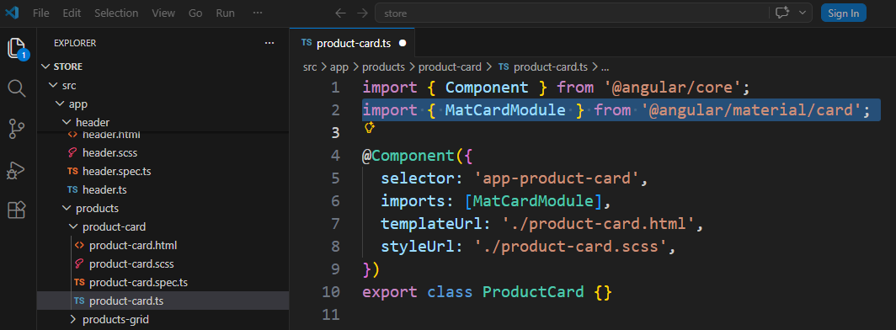

In case you forget about the material, can go back to the Angular Material Page.
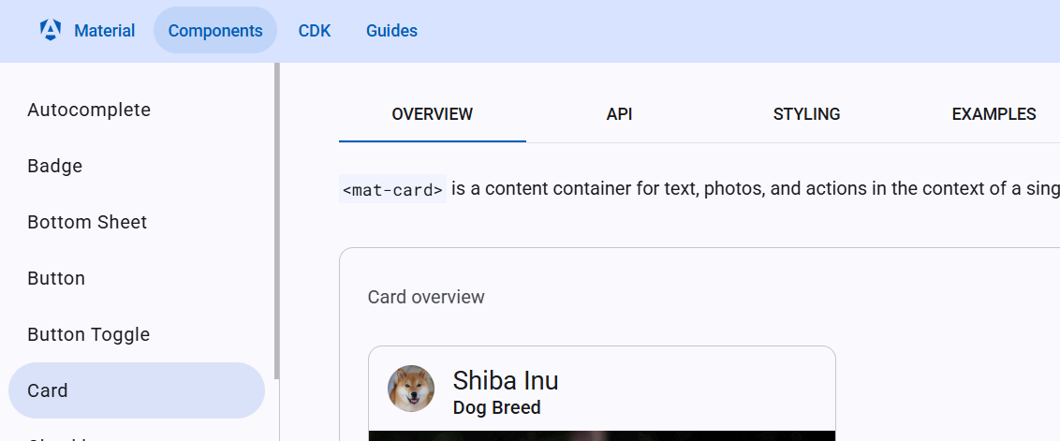

- Design Product-Card template. In product-card.html
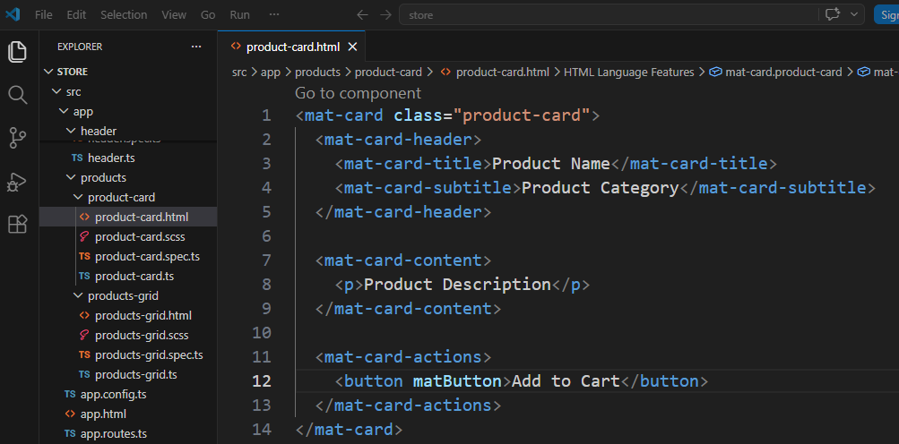
- Add SCSS script to Product-Card component
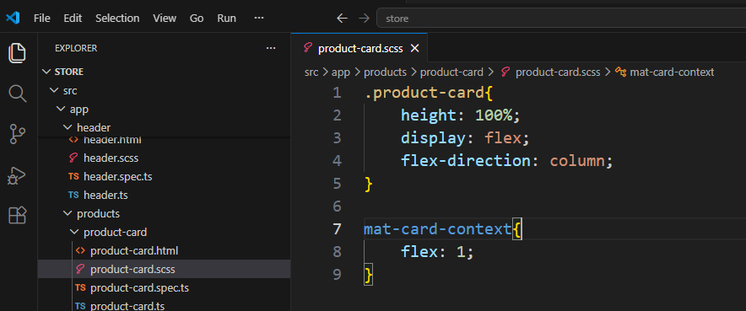

- Add this Cart component to Products/ products-grid.html
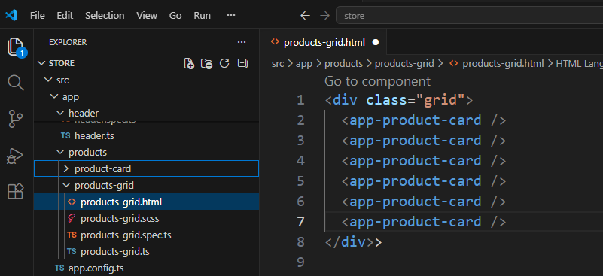

- In the Products/ products-grid.scss
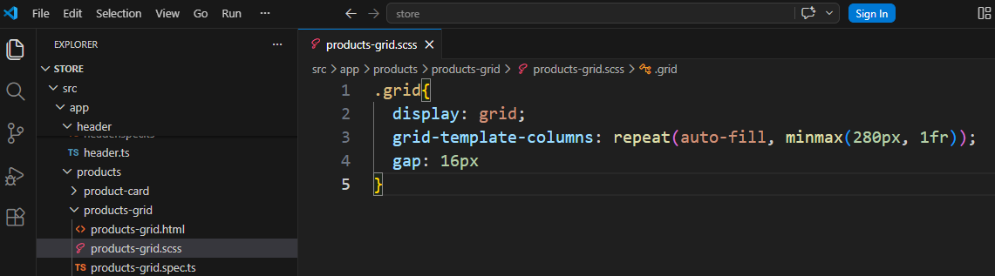

- Save All. Now the web page should look like this
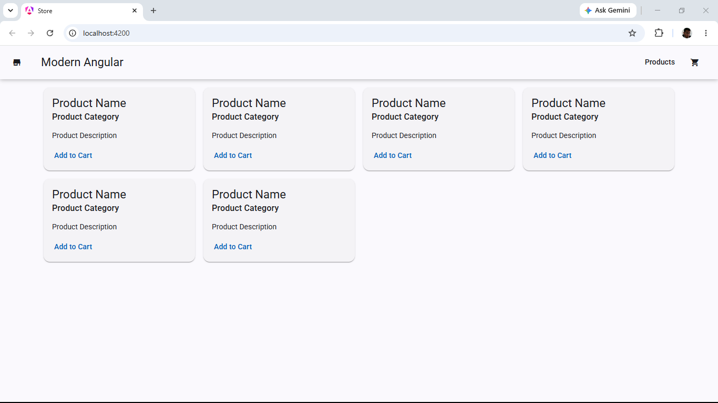
You can try to resize the browser window and see the effect.
- Close VS Code
- Backup/Zip the application as store(Ex09).7z

